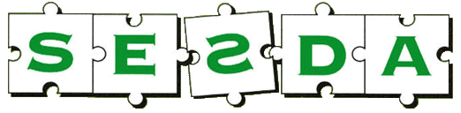
SOUTH EAST SURREY DYSLEXIA ASSOCIATION
Affiliated to the British Dyslexia Association SESDA Reg. Charity no.281076

Support Evening for Parents and Carers
New venue - Canada Hall, All Saints Church,
Battlebridge Lane, Merstham RH1 3HA

Tuesday 28th January 2025
8pm to 10pm

Handwriting
Hannah Aitken, expert in handwriting and SESDA Com. member

Good, legible handwriting is a very important skill for children to master
A short talk about practical ways to help achieve this aim at home and school
plus
A chance for parents and carers to meet Committee members, who are themselves parents of dyslexic youngsters, and specialist tutors, to talk about any concerns about dyslexia at home or school.

Canada Hall, All Saints Church,
Battlebridge Lane, Merstham RH1 3HA

SESDA Helpline: 01737 556173 E-mail: sesdadyslexia@hotmail.com

