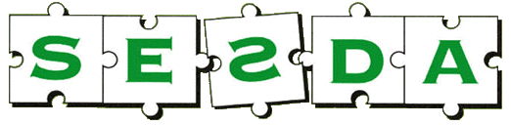

**SOUTH EAST SURREY DYSLEXIA ASSOCIATION**

**Affiliated to the British Dyslexia Association SESDA Reg. Charity no. 281076**

Teachers, Support Staff, Parents

**‘AI at Home’**

***An introduction to AI including how it is used within school by both staff and students***

***Speaker: David Curran***

**Assistive Technology Lead/Head of Careers at Moon Hall School**

***Tuesday 6th May 2025 at 7.30pm***

***Members (per family) £3.00***

***Non-Members (per family) £6.00***

**Places will be limited so please email** [sesdadyslexia@hotmail.com](mailto:sesdadyslexia@hotmail.com) **to book your place**

***There will be a fund-raising raffle***

***The meeting will be held at***

***Canada Hall, All Saints Church***

***Battlebridge Lane, Merstham RH1 3LH***

***Details from SESDA Helpline: 01737 556173***

***Or email;*** [***sesdadyslexia@hotmail.com***](mailto:sesdadyslexia@hotmail.com)